*Info About Animals*

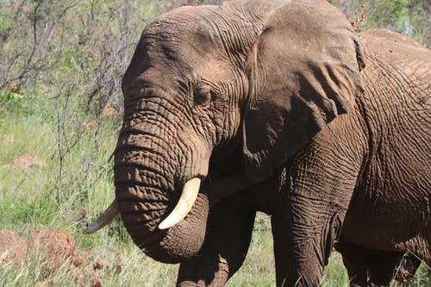

COMMON NAME: African elephants

SCIENTIFIC NAME: Loxodonta africana

TYPE: Mammals

DIET: Herbivore

GROUP NAME: Herd

AVERAGE LIFE SPAN IN THE WILD: Up to 70 years

SIZE: Height at the shoulder, 8.2 to 13 feet

WEIGHT: 2.5 to seven tons

SIZE RELATIVE TO A 6-FT MAN

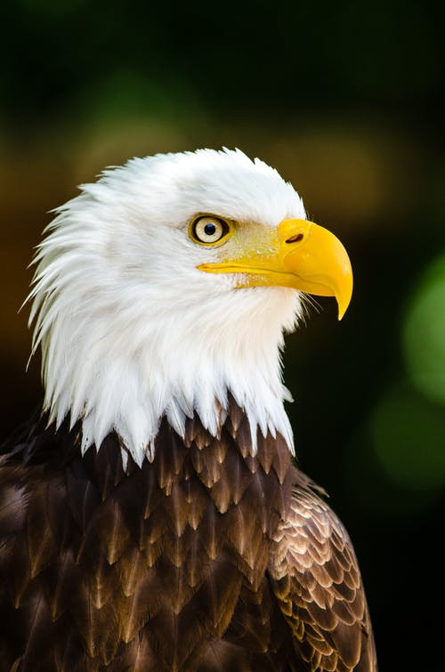

COMMON NAME: Bald Eagle

SCIENTIFIC NAME: Haliaeetus leucocephalus

TYPE: Birds

DIET: Carnivore

AVERAGE LIFE SPAN IN THE WILD: Up to 28 years

SIZE: Body: 34 to 43 inches; wingspan: 6 to 8 feet

WEIGHT: 6.5 to 14 pounds

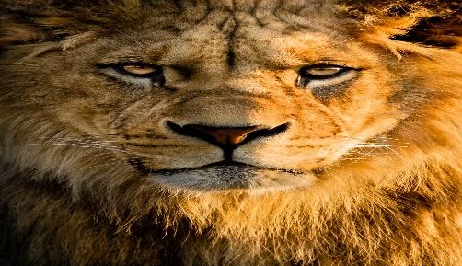

COMMON NAME: Lions

SCIENTIFIC NAME: Panthera leo

TYPE: Mammals

DIET: Carnivore

GROUP NAME: Pride

SIZE: Head and body, 4.5 to 6.5 feet; tail, 26.25 to 39.5 inches

WEIGHT: 265 to 420 pounds

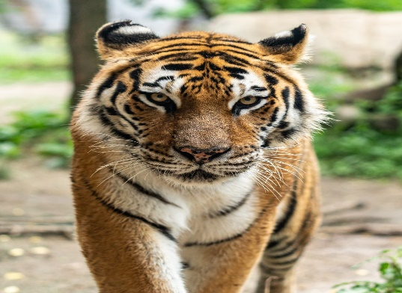

COMMON NAME: Tiger

SCIENTIFIC NAME: Panthera tigris tigris

TYPE: Mammals

DIET: Carnivore

AVERAGE LIFE SPAN IN THE WILD: 8 to 10 years

SIZE: Head and body: 5 to 6 feet; tail: 2 to 3 feet

WEIGHT: 240 to 500 pounds

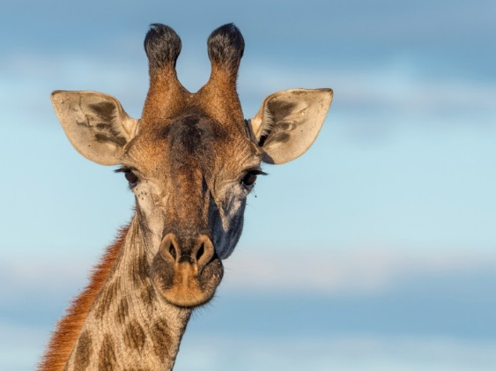

COMMON NAME: Giraffe

SCIENTIFIC NAME: Giraffa camelopardalis

TYPE: Mammals

DIET: Herbivore

AVERAGE LIFE SPAN IN THE WILD: 25 years

SIZE: 14 to 19 feet

WEIGHT: 1,750 to 2,800 pounds

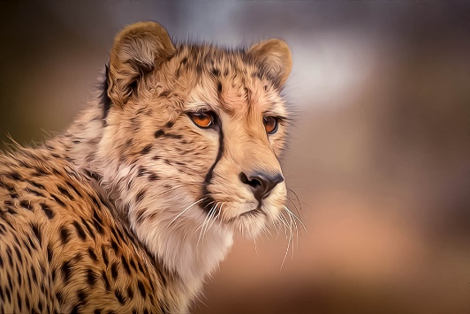

COMMON NAME: Cheetah

SCIENTIFIC NAME: Acinonyx jubatus

TYPE: Mammals

DIET: Carnivore

AVERAGE LIFE SPAN IN THE WILD: 10 to 12 years

SIZE: 3.5 to 4.5 feet; tail: 25.5 to 31.5 inches

WEIGHT: 77 to 143 pounds

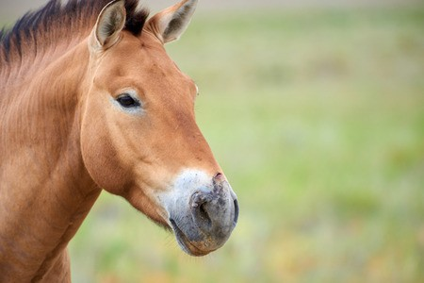

COMMON NAME: Horse

SCIENTIFIC NAME: Equus ferus caballus

TYPE: Mammals

DIET: Herbivore

SIZE: Height at the shoulders: 30 to 69 inches

WEIGHT: 120 to 2,200 pounds

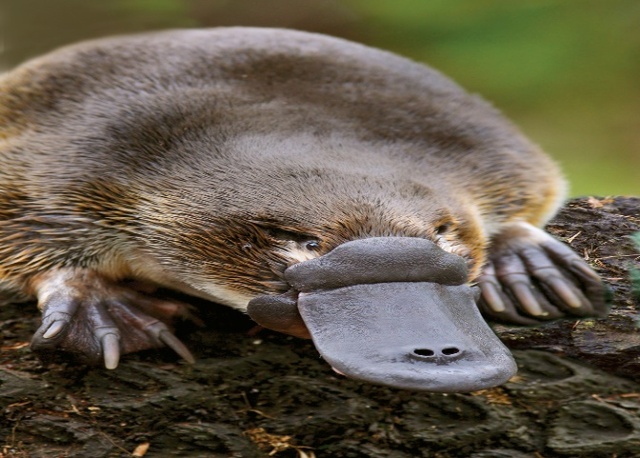

COMMON NAME: Platypus

SCIENTIFIC NAME: Ornithorhynchus anatinus

TYPE: Mammals

DIET: Carnivore

SIZE: Head and body: 15 inches; tail: 5 inches

WEIGHT: 3 pounds

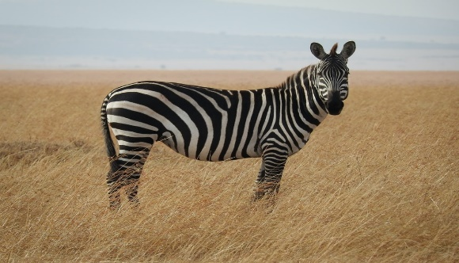

COMMON NAME: Zebra

SCIENTIFIC NAME: Equus quagga

TYPE: Mammals

DIET: Herbivore

GROUP NAME: Herd

AVERAGE LIFE SPAN IN THE WILD: 25 years

SIZE: Height at the shoulder: 3.5 to 5 feet

WEIGHT: 440 to 990 pounds

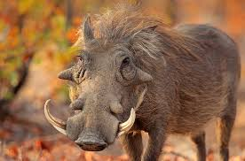

COMMON NAME: Warthog

SCIENTIFIC NAME: Phacochoerus africanus

TYPE: Mammals

DIET: Herbivore

GROUP NAME: Sounder

AVERAGE LIFE SPAN IN THE WILD: 15 years

SIZE: Height at shoulder: 30 inches

WEIGHT: 120 to 250 pounds

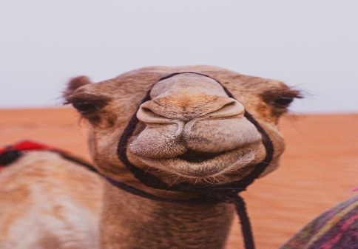

COMMON NAME: Camel

SCIENTIFIC NAME: Camelus dromedarius

TYPE: Mammals

DIET: Herbivore

GROUP NAME: Caravan, flock

SIZE: Over 7 feet tall at the hump

WEIGHT: Up to 1,600 pounds

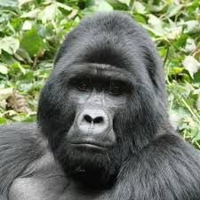

COMMON NAME: Gorilla

SCIENTIFIC NAME: Gorilla beringei beringei

TYPE: Mammals

DIET: Omnivore

GROUP NAME: Troop, band

AVERAGE LIFE SPAN IN THE WILD: 35 years

SIZE: Standing height: 4 to 6 feet

WEIGHT: 300 to 485 pounds